PUBLIC CONSULTATION

Better Broadband for Norfolk – Tranche Three

New procurement to further extend coverage of Next Generation Access (NGA) Broadband across the Norfolk.

1. INTRODUCTION AND BACKGROUND

The Better Broadband for Norfolk – Tranche Three is striving to extend the availability of NGA broadband infrastructure. By the end March 2020, Norfolk expects to achieve access to Superfast coverage for 95% of properties.

Better Broadband for Norfolk aims to provide access for as near to 100% of properties as possible. Better Broadband for Norfolk intends to procure further coverage of NGA broadband infrastructure (capable of delivering download speeds of at least 30 Mbps) in areas within its Programme Area where such broadband will be unavailable.

Geographically, Norfolk covers a very large rural county with a land area of 549,751 hectares. Approximately forty-five percent of the population reside in just four large urban areas, the city of Norwich and the three large towns of Great Yarmouth, King’s Lynn and Thetford. Better Broadband for Norfolk is now looking to provide NGA access to further premises across its area.

Rural Norfolk is relatively sparsely populated and that population is also dispersed across the whole county (i.e. there are no natural features, mountains, major lakes, or moorland that tend to concentrate people into confined settlements). The county’s population density in 2011 was 1.61 persons per hectare, which is the sixth lowest of the 27 shire counties - though with 537,066 hectares, Norfolk is the fifth largest in land area.

Better Broadband for Norfolk conducted its first Open Market Review (OMR) in June 2012. The OMR indicated that planned commercial coverage for NGA broadband would reach approximately 42% of premises within the next 3 years, and would therefore leave the remaining 58% of premises without access to NGA broadband. In December 2012, Better Broadband for Norfolk selected BT Group Ltd to deliver NGA broadband to these premises.

In the 2013 Spending Review, the Government announced a further allocation of funding under the Broadband Delivery UK (BDUK) Superfast Programme, with the aim of increasing NGA coverage across the UK to at least 95% by the end of 2017. Better Broadband for Norfolk was allocated £9.21m of additional public funding from the BDUK Superfast Programme, and has raised match funding for this allocation from its own resources. Following an open procurement, a contract for Better Broadband for Norfolk Superfast Extension Programme (at a value of £18.8 million) was awarded by Better Broadband for Norfolk to BT Group Ltd.

Better Broadband for Norfolk now intends to conduct a further open procurement in respect of the remaining area without NGA broadband infrastructure (known as “white NGA”), which comprises around 46,000 premises. It should be noted that the number of properties in Norfolk has increased by approximately 10% since the previous Better Broadband for Norfolk procurement.

BDUK received approval on 26 May 2016 from the European Commission on its new National Broadband Scheme for the United Kingdom (referred to hereafter as the 2016 NBS). Better Broadband for Norfolk intends to conduct this further procurement under the 2016 NBS.

2. MARKET ENGAGEMENT AND ANALYSIS OF EXISTING COVERAGE

In preparation for this procurement, Better Broadband for Norfolk conducted an new OMR between 27th November 2017 and 26th February 2018 to establish existing and planned (within the next 3 years) coverage of broadband infrastructure across the Better Broadband for Norfolk Area. This included both commercial coverage by existing and prospective NGA broadband infrastructure providers and coverage procured under Better Broadband for Norfolk’s existing contracts with BT Group Ltd.

Better Broadband for Norfolk contacted all known broadband infrastructure operators within the Programme Area and other providers known to have (or potentially having) plans to deploy new networks across the UK with a formal request for information. The OMR was also publicised through the Better Broadband for Norfolk website. Operators were requested to provide information on their existing and planned NGA broadband infrastructure (capable of delivering download speeds of at least 30 Mbps), and to provide detail of their coverage at a premise level so as to enable greater granularity of mapping.

This information, together with Better Broadband for Norfolk's own data sources, has been used to define the proposed intervention area for the forthcoming procurement.

This public consultation sets out that proposed intervention area, so as to enable all interested stakeholders (including the public, businesses, internet service providers and broadband infrastructure operators) to comment on the proposals. In particular, this provides an opportunity for broadband infrastructure operators to review Better Broadband for Norfolk’s mapping to ensure that it correctly represents the information provided by them in the course of the OMR.

All responses to the public consultation will be carefully considered and where necessary will be incorporated into the final map of the intervention area. The final intervention area maps and a summary report confirming details of the changes made to the proposed intervention area will be published on the Better Broadband for Norfolk website shortly after the close of the consultation period. Where responses to the consultation are received, Better Broadband for Norfolk will respond to these and provide an explanation of how the information submitted has been treated. The finalised intervention area will then be submitted to BDUK’s National Competence Centre (NCC) for approval against the State aid Framework.

3. STATE AID FRAMEWORK AND RULES

This section provides a brief introduction to the State aid Framework for the purpose of informing responses to the public consultation. Respondents may wish to obtain their own professional/legal advice on the application of the State aid Framework and rules that relate to this proposal.

The European Commission has published ‘EU Guidelines for the application of State aid rules in relation to the rapid deployment of broadband networks’ (2013/C 25/01’.These guidelines summarise the principles of the Commission’s policy in applying the State aid rules of the Treaty to measures that support the deployment of broadband networks, and seek to ensure that State aid schemes for broadband are well-designed so that they target market failures and minimise negative effects on competition.

The guidelines require public interventions to be targeted so as to limit the risk of crowding out private investments, of altering commercial investment incentives and ultimately of distorting competition.

Planned public interventions can seek State aid approval directly from the Commission, or (as is the case with this proposal) seek clearance under a national scheme which has been pre-approved by the Commission.

Projects under the 2016 NBS will need to demonstrate their State aid compliance (in accordance with the terms of the scheme) in order to receive clearance from BDUK’s National Competence Centre.

The Commission’s guidelines distinguish between two types of broadband networks, namely basic broadband and NGA networks.

Basic broadband networks are generally those based on currently widely-deployed technologies such as fixed wired telephony networks (using ADSL/ADSL2+ technologies), non-enhanced cable TV networks (eg DOCSIS 2.0), mobile networks (2G/3G (UMTS)), some fixed wireless access (FWA) networks, and satellite networks.

NGA networks rely wholly or partly on optical elements (optical fibre) and are capable of delivering an enhanced broadband capability compared to existing basic broadband networks. Current qualifying NGA technologies are fibre-based networks (FTTx), advanced upgraded cable networks (DOCSIS 3.0) and certain advanced wireless access networks capable of delivering reliable high speeds.

Guidance on the characteristics of qualifying NGA technologies is available from BDUK.

The Commission’s guidelines also require that public intervention should be able to ensure a ‘step change’ in broadband availability. This is demonstrated by:

- Significant new investments in the broadband network;
- The new infrastructure brings significant new capabilities to the market in terms of broadband service availability and capacity, speeds and competition;

The ‘step change’ in broadband availability shall be compared to that of existing as well as concretely planned networks.

The Commission’s guidelines also distinguish between geographic areas on the basis of their existing or planned broadband infrastructure:

- ‘White’ areas are those in which there is no qualifying broadband infrastructure and none is likely to be developed within 3 years;
- ‘Grey’ areas are those where only one network is present or is to be deployed within the coming 3 years; and
- ‘Black’ areas are those where at least two networks of different operators exist or will be deployed in the coming 3 years.

This geographic mapping of White/Grey/Black areas is carried out separately in relation to basic broadband and NGA networks. NGA networks are mapped on the basis that, amongst other things, they have substantially higher upload speeds (compared to basic broadband networks) and are able to deliver broadband services at an access (download) speed of more than 30Mbps.

Public intervention can only take place in white NGA areas under the 2016 NBS. White NGA areas are those in which there are no NGA networks and none is likely to be developed within the next 3 years.

- PROPOSED INTERVENTION

In the absence of premise level data from broadband infrastructure operators, Better Broadband for Norfolk has mapped areas as white, grey, black or blue at a postcode level, using the following criteria:

For basic broadband,

- A postcode is turned grey if there is only one broadband infrastructure operator providing basic broadband services (with speeds greater than 2 Mbps) to that postcode.

- A postcode is turned black if there are at least two broadband infrastructure operators providing basic broadband services (with speeds greater than 2Mbps) to that postcode.

- All other postcodes remain white. As all properties within Norfolk have access to the Government’s Better Broadband Subsidy scheme there are no postcodes mapped as Basic White

For NGA,

- A postcode is turned grey if there is only one broadband infrastructure operator providing NGA services (with speeds greater than 30Mbps) to that postcode.

- A postcode is turned black if there are at least two broadband infrastructure operators providing NGA services (with speeds greater than 30Mbps) to that postcode.

- All other postcodes remain white.

In addition, the proposed intervention area includes a number of “under review” areas (coloured blue on the map). * These areas have previously been indicated to have planned commercial coverage for NGA broadband (i.e. mapped as grey or black NGA), but those plans have been reported through the OMR as being ‘at risk’ of not being completed. These areas will be subject to continued monitoring and verification of supplier plans within the 3 year period by Better Broadband for Norfolk and in the event that these commercial plans fall away these premises will be mapped as white NGA and form part of the proposed intervention area and eligible for intervention via this aid measure.

The mapping analysis of existing and concretely planned coverage (within the next 3 years) has identified significant remaining ‘white NGA’ areas. The outcome of the OMR is summarised in terms of NGA White, Grey, Black and ‘Under Review’ premises below.

 | Number of Postcodes | Number of Black Premises | Number of Grey Premises | Number of White Premises
White | 6,770 | 0 | 62,113 | 41,474
Grey | 15,687 | 19,506 | 237,256 | 0
Black | 3,722 | 83,956 | 0 | 0
‘Under Review’ | 982 | 0 | 21,539 | 4,200

Better Broadband for Norfolk intends to procure coverage to target the remaining ‘white NGA’ areas as follows:-

- By conducting a new procurement under the 2016 NBS (and in accordance with the Public Contracts Regulations 2015); and

- By utilising project/programme efficiencies obtained under Better Broadband for Norfolk; and

- Based on a bid to DEFRA for funding to specifically target rural businesses which have been identified as economically important, assuming this bid is successful

As noted above, if commercial plans fall away in the ‘under review’ areas then these will be considered as eligible for intervention and considered as ‘white NGA’ areas.

If it is possible, Better Broadband for Norfolk intend to make coverage information available at a premises level within the identified white postcode areas to bidders to ensure that bids can target those premises without NGA broadband coverage efficiently. This will include information at a premises level received in response to this consultation.

It should be noted that whilst this consultation includes mapping of basic broadband coverage, the procurement will not deploy basic broadband technologies. The intention is to provide bidders with details of all the areas where there is basic broadband coverage so as to ensure, so far as possible, that these areas are only overbuilt by NGA broadband infrastructure where the premises will receive over 30Mbps or at least a doubling of speeds, in accordance with the requirements of the 2016 NBS. Where doubling is not possible, the supplier will be obliged to demonstrate that the design is optimised to limit the over build of existing basic broadband networks with speeds that are below 30Mbps.

  - New Procurement

Better Broadband for Norfolk commenced extensive market engagement and warming in November 2017, held a ‘Bidder Information Day’ in 24th January 2018 and has issued its outline requirements to enable feedback from potential bidders to be taken into account in the design of the scheme and to understand the capacity and capability of the market.

Better Broadband for Norfolk has also considered the ability of the private sector to deliver the project, available resources, and its own capacity and capability to develop its approach to intervention. It has decided that the project will use an investment gap funding approach to procure an infrastructure provider.

The procurement will be carried out in accordance with the Public Contracts Regulations 2015 and EU Public Procurement Directives. The tender is most likely to utilise the Open Procedure and will be conducted in a transparent and non-discriminatory manner, as required by the 2016 NBS.

The procurement will be designed to meet the specific requirements of the 2016 NBS, which recognises the need to optimise the number and quality of bidders, in particular by reducing the hurdles to participation in procurements by smaller suppliers and encouraging collaboration between larger and smaller operators so that a range of appropriate solutions can be brought forward. This was also a key objective of the market engagement exercise. When the procurement is launched, based on supplier feedback, the white areas are not likely to be sub-divided into a number of lots or areas.

Better Broadband for Norfolk’s priority will be to ensure that the available public funding is used most effectively by ensuring coverage of premises currently getting relatively slow broadband speeds (<24 or <15 Mbps)*. However, areas with higher speeds may be targeted, subject to the need to provide a ‘step change’ in broadband capability (as outlined above).

In total public funding of up to £18 million may be committed via the forthcoming procurement.

- Timescales

This consultation will be open until 4th May 2018.

Once the consultation is closed and Better Broadband for Norfolk has finalised the intervention areas, an Invitation to Tender (ITT) will be issued via Norfolk County Council’s procurement portal to suppliers to bid for the opportunity to deliver extended NGA broadband coverage during May 2018. The intention is to award a contract during 2018. The related extended deployment plans for broadband infrastructure should begin by 2019.

- State Aid Public Consultation

The EU Guidelines (at paragraph 78) and the 2016 NBS set out the requirements to hold a public consultation in order to validate the intervention area mapping by allowing all interested stakeholders an opportunity to comment on the planned aid measure.

The purpose of this document is to fulfil those requirements by publishing a description of the proposed aid measure, and seeking feedback from all interested stakeholders. The mapping for basic and NGA broadband are shown in the attached maps.

The attached map of the NGA broadband Intervention Areas relies on the definitions of white, grey and black areas, as set out in the EU Guidelines (and as summarised above). Better Broadband for Norfolk will only target the areas identified as White on the map. However, if the areas of commercial coverage currently identified as ‘Under Review’ fall away then these areas could potentially be added to the contract intervention area.

This State aid public consultation and the proposed NGA broadband Intervention Area maps are available to all stakeholders on the Better Broadband for Norfolk website at http://www.betterbroadbandnorfolk.co.uk/further-information/ and will also be available via BDUK’s website at BDUK Table of local broadband projects.

- Responding to this State Aid Public Consultation

Better Broadband for Norfolk is requesting information and supporting evidence in relation to basic and NGA broadband infrastructure within the project area and wish to hear from all relevant stakeholders (including residents, businesses as well as broadband infrastructure operators), particularly in relation to areas to be targeted as part of the NGA intervention area at Annex [A].

For the avoidance of doubt, there is no need to respond to this public consultation if you have no comment to make.

For residents and businesses, where this relates to the ability to receive an NGA service, any information provided in response to this State Aid public consultation should as a minimum include (but need not be limited to) the address of the property or area that the submission relates to and the nature of the concern.

If the response is from an infrastructure provider and comments on the white, grey and/or black or under review classifications within the attached maps or data, or on the wholesale products to offered via the subsidised network, then the submission should also include the specific information set out in Section 8.
For all submissions, Better Broadband for Norfolk would be grateful if you would contact Better Broadband for Norfolk to register your intention to submit a response and could confirm in your submission the following:

- Your organisation’s name (if applicable)
- Your organisation’s address (if applicable)
- Your name
- Position
- Contact telephone number
- Email Address

Better Broadband for Norfolk will then arrange access to the Response Template.

Better Broadband for Norfolk also requests confirmation from an authorised signatory that the information provided is suitably accurate and up to date.

Please send your responses no later than 4th May 2018 to:

Karen O’Kane

C/O: Karen.okane@norfolk.gov.uk

Please note that the data you provide in your response will be treated as commercially confidential to your organisation. However, it may be necessary to share/some all of your response data with our professional advisers and/or DCMS/BDUK, Ofcom, the National Competence Centre and the European Commission in the course of seeking State aid approval.

It should also be noted that it is a State aid requirement to use this information to produce State aid maps to define white, grey and black areas for basic and NGA broadband. However, the published maps will show the aggregated White/Grey/Black NGA and Basic Broadband areas, not the data provided on a per-operator basis. The final maps that will be used for procurement purposes will be published shortly after the conclusion of this State aid public consultation and once approved by the National Competence Centre.

If you have any questions about any of the above, please contact the Better Broadband for Norfolk by email as above.

- Information Requested

This section specifies the information you are requested to provide in response to this State aid public consultation in relation to the presence of broadband infrastructure.

Better Broadband for Norfolk is requesting information on, and supporting evidence for, any current or planned (within the next 3 years) investment in broadband infrastructure in the Better Broadband for Norfolk Area, where this may not be already included within the proposed NGA and Basic broadband intervention area maps attached.

For any current or planned coverage not included within the proposed State aid intervention areas shown on the attached map, Better Broadband for Norfolk is requesting information at premise level, using the template issued by Better Broadband for Norfolk on 27th November 2017 to show existing or planned coverage by your broadband infrastructure investment. By ‘covered’ (or ‘passed’) Better Broadband for Norfolk means that fixed network infrastructure is or will be available to the premises, potentially subject to a final drop connection, or that the premises are able to receive a suitable quality radio signal over the air interface, potentially subject to the installation of a suitable antenna.

Any information provided in response to this State aid public consultation should include, but need not be limited to:

- Detailed maps for NGA broadband showing existing and planned coverage, for at least the next 3 years.
- Details of premises covered or passed that fixed network infrastructure is or will be available to the premises within the next 3 years, potentially subject to a final drop connection, or that the premises are able to receive a suitable quality radio signal over the air interface, potentially subject to the installation of a suitable antenna.
- A detailed description of the technology solution(s) deployed (or to be deployed) in your broadband infrastructure, demonstrating how they meet the minimum standards as set out in the BDUK NGA Technology Guidelines.
- A description of the services/products currently offered, and separately those services/products to be offered within the next 3 years.
- Installation, annual/monthly subscription, and additional volume or per-service tariffs for those services/products (identifying whether such tariffs are inclusive or exclusive of VAT).
- Upload and download speeds typically experienced by end-users, and how these may vary by factors such as distance, increased take-up or demand, contention, etc.
- Appropriate indicators of the quality of services (e.g. contention ratios, bandwidth allocation per user, etc), including any characteristics (e.g. latency, jitter) that are required to support advanced services such as video conferencing or HD video streaming.
- Evidence to substantiate actual or planned coverage claims, including business cases and evidence of available funding to enable plans to be fulfilled.
- Details and planned timing of roll-out of any future investments, including further investments required to cope with future increases in take-up or demand.

Please supplement the required information above with any supporting evidence as you consider appropriate (e.g. links to public websites).

Better Broadband for Norfolk would also be interested to hear from operators their views as to the types of wholesale access products they would like to see offered on any newly created subsidised NGA network infrastructure. This information may inform the intervention design. Please note that we are not obliged to include these products in the invitation to tender (unless already required under any State aid Decision).

8. Next Steps

Following any responses received to this State Aid public consultation by the closing date of 4th May 2018, Better Broadband for Norfolk plans to publish the final Intervention Area maps shortly after the close of the consultation period.

This will be followed by the launch of the ITT to Suppliers to bid for the opportunity to fulfil a new contract to deliver the extended coverage.

Information about the Better Broadband for Norfolk programme can be found at:

http://www.betterbroadbandnorfolk.co.uk/

Annex A

NGA Broadband Map

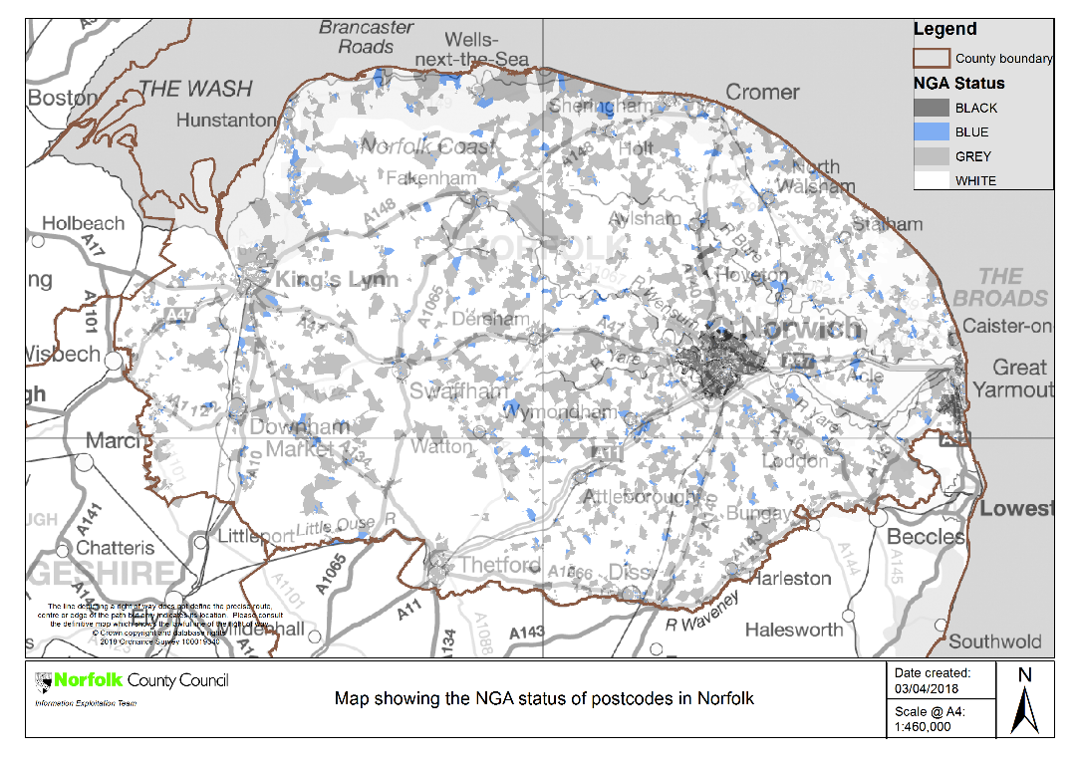

This document contains NGA postcode level data

Basic Broadband Map
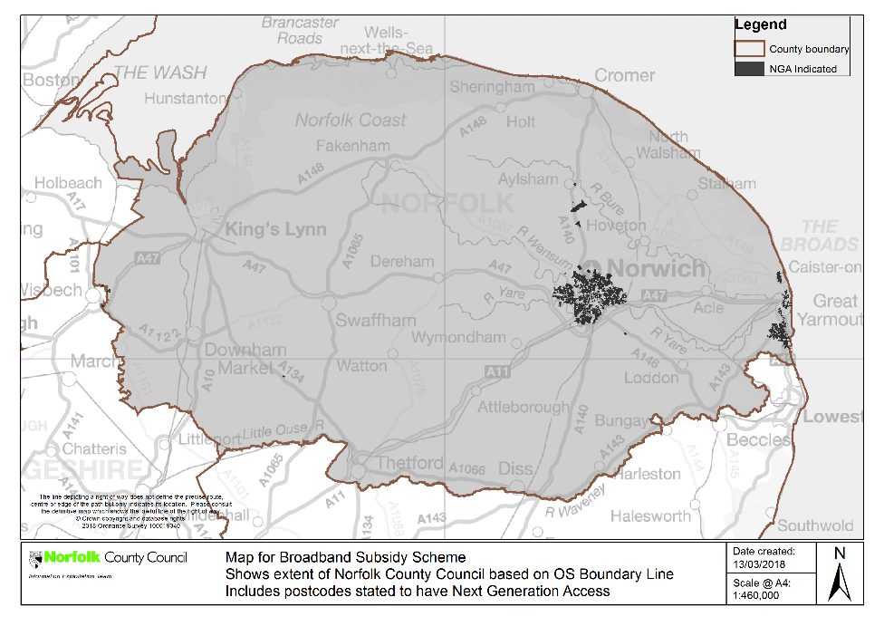
This document contains Basic postcode level data

Please not all Norfolk postcodes are classified as Basic Grey or Black. This is because all properties have access to the Government Better Broadband Subsidy Scheme

http://eur-lex.europa.eu/LexUriServ/LexUriServ.do?uri=OJ:C:2013:025:0001:0026.EN.PDF
https://www.gov.uk/government/publications/2016-nbs-tech-guidelines
See Footnote 66 of the Commission’s Guidelines - this sets out that the subsidised network should be pro-competitive (i.e. allow for effective access at different levels of the infrastructure).
Substantially higher upload speeds means at least a doubling of the maximum upload speed available on current generation access network(s) for given ‘up to’ packages available on basic broadband networks in the relevant intervention area. * Delete as appropriate if premises level data provided.
See paragraph 65 of the Commission’s guidelines.
The white premises in these postcodes will be subject to monitoring and review as explained above.
Operators will still be able to request new forms of access products on the subsidised NGA network infrastructure through the formal general access provisions under the terms of a future State aid Decision.

