Open Market Review Template

BETTER BROADBAND FOR NORFOLK

REQUEST FOR INFORMATION

1. INTRODUCTION

Better Broadband for Norfolk strive to provide the best broadband connectivity possible across its programme Area. The county of Norfolk which is a two tier area including Norfolk County Council, and seven District / Borough Councils; Breckland, Broadland, Great Yarmouth, Kings Lynn & West Norfolk, North Norfolk, Norwich and South Norfolk . The overarching aspiration of Better Broadband for Norfolk is to deliver ‘access to Superfast broadband for all by the end of 2020.’

2. GEOGRAPHICAL SCOPE

As described above, our Area encompasses the 470,044 premises that are defined within a spreadsheet which details the postcodes and associated premises. The postcode / address data has been sourced from AddressBase Premium. The data was ordered from the Ordnance Survey on the 23rd October 2017 (ref. 000285473). See section 6 for further details.

A map of this area is shown at the foot of this document and is also available in a GIS format upon request.

3. PROGRESS TO DATE

Our initial Local Broadband Plan was approved in 2011, covering an Intervention Area of some 233,709 premises that were assessed as being outside the scope for normal commercial NGA investment through an open market review process.

The phase 2 contract signed in December 2014 aims to achieve 95% superfast broadband coverage to the Programme Area by end March 2020 and in line with the UK Government’s targets, we are seeking to substantially contribute to the Government objective of at least 95% superfast coverage nationally by the end of 2017 though our phase 2 contract.

A new procurement is intended with the objective of achieve Superfast access for as close to 100% of Norfolk properties, as available funding will allow. Expected funding sources include:

- Current and future Project Savings from the first two Better Broadband for Norfolk contracts will be recycling into a new phase 3 procurement.
- Any funding generated from a bid to the DEFRA Rural Broadband Grant fund
- Potential new financial contributions from public sector organisations

Details of these and any restrictions on their usage will be explained in our forthcoming tender documentation. It is therefore Better Broadband for Norfolk’s intention to procure Next Generation Access solutions – those capable of achieving a minimum of 30 Mbps download speed - for the remaining area in scope for NGA deployment.

4. PURPOSE OF THIS OMR

As part of this new procurement process, we are now commencing an Open Market Review (“OMR”) to establish existing and planned (next 3 years) commercial coverage of broadband services across the Better Broadband for Norfolk Area by all existing and any prospective, NGA broadband infrastructure providers.

This OMR is intended as a precursor to a formal public consultation document. The UK applies a best practice process that promotes the use of both an Open Market Review (“OMR”) and a Public Consultation, the latter being conducted in a manner consistent with the requirements of the Broadband Guidelines. We consider that early market engagement at this stage is an essential and extremely important part of our early market research The results of the OMR will assist us with understanding the broadband infrastructure (Next Generation Access (NGA)) already in place and where there are plans for investment in such infrastructure in the coming three years and a significant step in the design of the intervention area to be targeted by the new contract.

Once we have defined these Intervention Areas from the OMR, we will be conducting a minimum one month State aid public consultation on our proposed Intervention Areas. We propose to launch our ITT in the financial year 2018/19.

5. YOUR RESPONSE REQUIRED

We are sending this OMR to all recognised broadband infrastructure and internet providers in our area. In addition, we are publishing this OMR document on our website.

We require responses by 31 January 2018: two months from publication to the questions set out in the Annex. A full response template incorporating a spreadsheet of our Intervention Area premises is available by emailing Karen.okane@norfolk.gov.uk. This must be done by 15th December 2017.

When responding, we would be grateful if you could confirm your organisation's name and address, as well as the name, position and contact details of the person responding on behalf of the organisation.

- The OMR Response Template will be released via email once a signed Partners Standard Form Contractor Licence, which can be found at the end of this document, has been returned to Better Broadband for Norfolk karen.okane@norfolk.gov.uk

Please note that the data you provide in your response will be treated as commercially confidential to Better Broadband for Norfolk, albeit that it may be necessary to share some/all of your response data with our professional advisors and/or DCMS/BDUK, Ofcom, BIS State Aid Branch and the European Commission in the course of seeking State Aid . It should also be noted that it is a State Aid requirement to utilise this information to produce State Aid maps to define white, grey and black areas for basic and NGA broadband. These maps will be published as part of the Public Consultation process and will be utilised to define the intervention area. However, please note that these published maps will be assimilated utilising data from all relevant operators and will not be directly attributed to a single source.

If you have any questions about any of the above, please contact Karen O’Kane from the Better Broadband for Norfolk Programme Team: karen.okane@norfolk.gov.uk

ANNEX
1. Please provide details and supporting evidence of any current or planned investment in broadband infrastructure (basic broadband and NGA broadband) in the Better Broadband for Norfolk area. In the case of planned investment, we are particularly interested in plans for the coming three years (to 30 November 2020). Beyond completion of the attached spreadsheet template (or instead of the spreadsheet if you are not able to provide the information in the required template form), any information provided in response to this request should include but not be limited to:

  - Premises detail for basic broadband and NGA broadband showing the existing coverage and separately maps detailing the planned investment in the basic broadband and NGA infrastructure networks for at least the next three years;

  - Exact detail of premises passed or covered, including information on the number of premises passed (in the case of a fixed network) or covered and able to receive services (in the case of a wireless/satellite network);

  - Details of the technology and where these claim to be NGA, demonstrate how they meet the minimum standards as set-out in the BDUK Technology Guidelines.

  - Description of the services/ products currently offered and separately those to be offered within the next 3 years;

  - Installation and rental tariffs for those services/products clearly identifying whether they are inclusive or exclusive of VAT;

  - Upload and download speeds typically experienced by end users;

  - Appropriate indicators of quality of the service e.g. contention ratio or bandwidth allocation per end user;

  - Evidence to substantiate actual or planned coverage claims including business cases and evidence of available funding to enable plans to be fulfilled.

  - Details and timing of roll-out for future investment; and

  - Confirmation from an authorised signatory that all information provided is of suitable accuracy.

Please supplement with supporting evidence as you consider appropriate e.g. public websites.

Thank you, Better Broadband for Norfolk
Map of Better Broadband for Norfolk geographic area

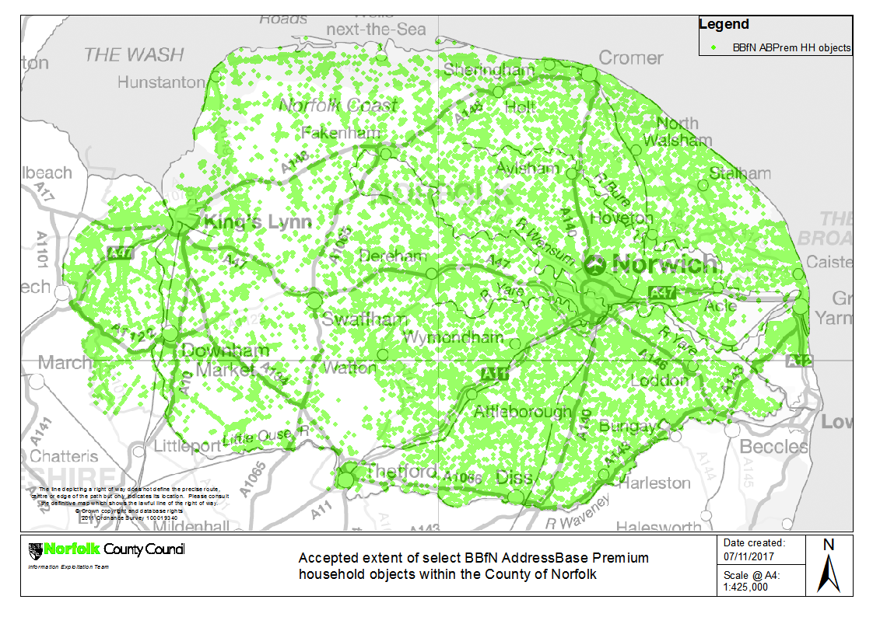

PSMA Standard Form Contractor Licence

Premises level template

Community Guidelines for the application of State aid rules in relation to rapid deployment of broadband networks http://eur-lex.europa.eu/LexUriServ/LexUriServ.do?uri=OJ:C:2013:025:0001:0026:EN:PDF
https://www.gov.uk/government/publications/2016-nbs-tech-guidelines

