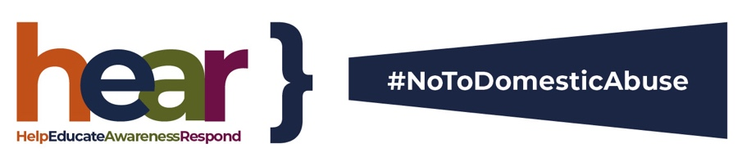

Pledge to help victims of domestic abuse
– how you can find help

Alongside all our partners and other organisations across the county, INSERT YOUR ORGANISATION NAME HERE, is working to ensure those vulnerable to domestic abuse know help is available and they need not suffer in silence.
The Covid pandemic has had a disproportionate impact on those who already face many challenges in the home – often more frightening during self-isolation or when working behind closed doors alongside an abuser.
However, (insert your agency name) is keen for victims to know there is someone there to help. Companies and employers have an important role to play in helping to prevent domestic abuse where it impacts on the workplace – and when a victim’s work, productivity and safety are affected – whether working at home or in the office.
As part of our commitment to helping victims, and to mark White Ribbon Day (www.whiteribbon.org.uk/day) this November, we have signed a countywide pledge which aims to raise awareness and educate employers about such abuse.

Employers’ pledge to help domestic abuse victims in the workplace
We pledge to break the silence around domestic abuse and HEAR, help and provide support in the workplace.

Help
Every employer has a duty to provide access to organisations who can help employees: We will ensure colleagues affected by domestic abuse are given access to the right specialist support.

Educate
Every employer should ensure the right training is provided: We will make sure the right training is provided to staff to know what steps to take to support colleagues.

Awareness
Every employer has a responsibility to be aware of domestic abuse: We will not tolerate domestic abuse in any form and will provide a supportive workplace for colleagues who experience such abuse.

Respond
Every employer should ensure the right policies are in place to respond to domestic abuse: We will review our policies and processes and ensure they are implemented correctly.
White Ribbon Day is a vital way of supporting victims of domestic abuse. On this day each year thousands of people stand up, speak out and say #NoToDomesticAbuse.
“This is however just one day and we must work together to prevent abuse and make sure our communities and homes are safe for everyone 365 days of the year.
“With more people opting to work from home due to the pandemic, it is incumbent upon us as employers to ensure those at risk of abuse know they will be heard and help and support is out there.

How to get help
The police will always respond to emergency calls if you are in immediate danger and there are many local charities and organisations still working to help you through this difficult period where you may feel more at risk.
If you know someone who is the victim of domestic abuse, we encourage you to seek help.
If you are in immediate danger you should still call 999. Police 101 is the non-emergency number.

Silent Solution
The Silent Solution system helps filter out accidental or hoax 999 calls from those who need genuine police assistance.
If you are calling from a mobile phone and speaking or making an immediate sound would put you in danger and you need immediate help, call 999 and stay on the line, then press 55 when prompted and the call will be transferred to the police, who will know it is an emergency call.
If you are calling from a landline, Silent Solution does not apply as it is less likely to call 999 by accident. If an emergency call is made and no one speaks and only background noise is heard and an operator does not know whether an emergency service is needed, you will be connected to a police call handler.
Information about where you are calling from on a landline will be automatically available to call handlers to help provide a police response.
For more information on local helplines and where to get support visit the following websites:
Norfolk County Council at www.norfolk.gov.uk/safety/domestic-abuse
Norfolk Constabulary at www.norfolk.police.uk/advice/assault-abuse-threats/domestic-abuse
The Office of the Police and Crime Commissioner for Norfolk at www.norfolk-pcc.gov.uk/services-we-provide/supporting-victims-and-protecting-the-vulnerable/help-for-victims-of-domestic-and-sexual-abuse

