The Provider Portal (Course Module) is the method to book courses, events and a place at a briefing session which are available as part of the Early Years Service Training Programme.

It will not be possible to book a training course or briefing session if the delegate is not listed within the Staff Module.

To access the module, it will be necessary to have existing access to the online Provider Portal.

The link to the online service is – www.norfolk.gov.uk/eyproviderportal

Once logged in to the online system, click COURSES

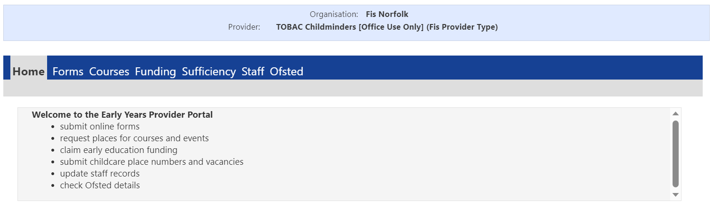
Providers and Groups are responsible for checking the progress of an application and keeping delegate information up to date via the Staff Module.

Details about courses, events and briefing sessions are widely advertised via our newsletters. It is also possible to find details on our training webpage and use the search facilities in the module.

When a place is requested (application), it is not secured until a confirmation is emailed to the delegate.
Please refer to our training webpage for more information –
- Applying for Training
- Frequently Asked Questions
- Cancellation policy

To find a course, event or briefing session, via the portal –
① | Click Early Years Training Directory  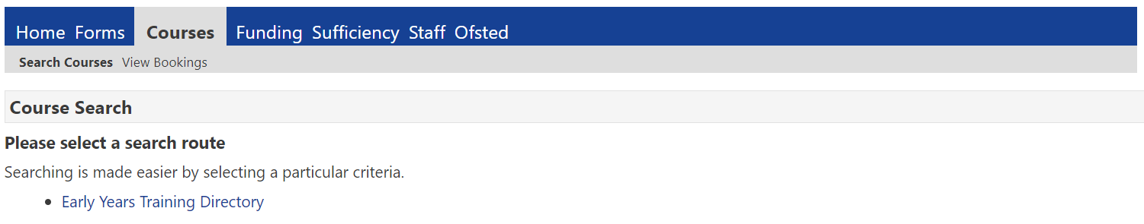
② | Search via the Course Code (found in the programme brochure)  OR complete an Advance Search by inserting Date, Description and Venue  Date format must = dd/mm/yy  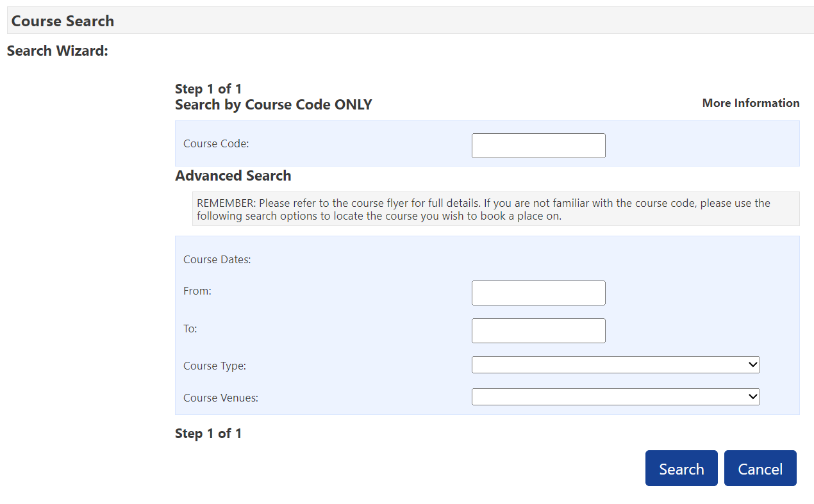  Search results are determined by the criteria options inserted. Avoid using all options to ensure the results are maximised.  BEST SEARCH RESULT: Course Code Only  Enter details and click SEARCH

To REQUEST a place (submit an application) –
The provider or group is responsible for –
- checking that the aims of the course, event or briefing session meets training need.
- any costs incurred to attend (unless detailed in the brochure).

Use the search wizard to find the course, event or briefing session

Your search results will be displayed –

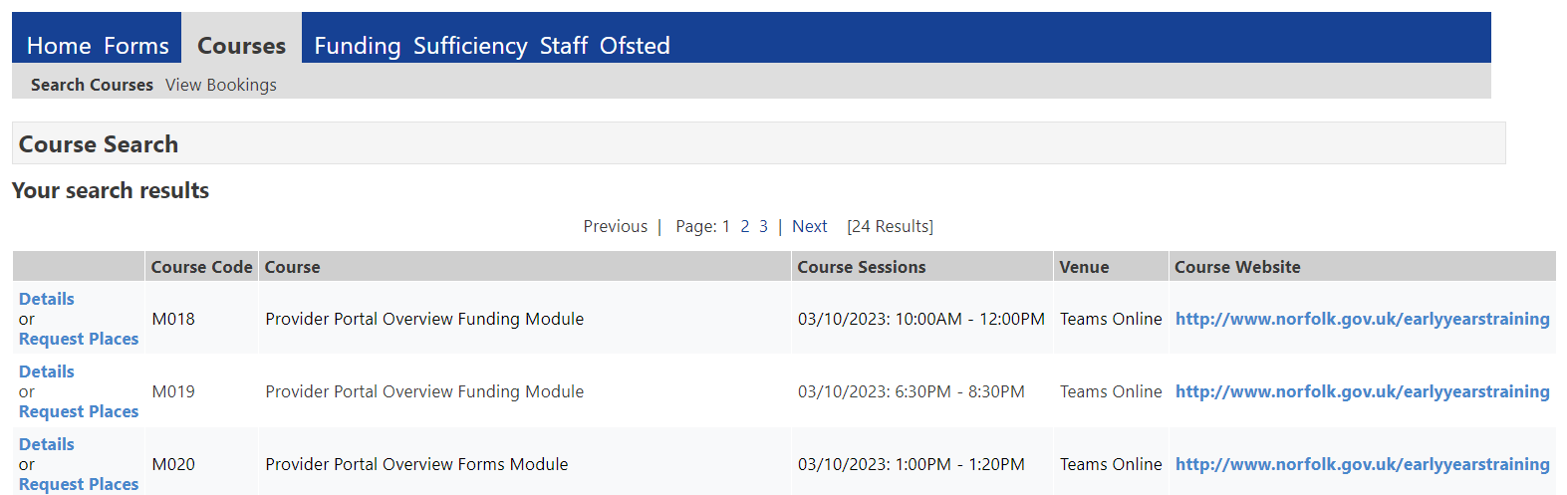
BEFORE requesting a place, please check the course details
and

screen details  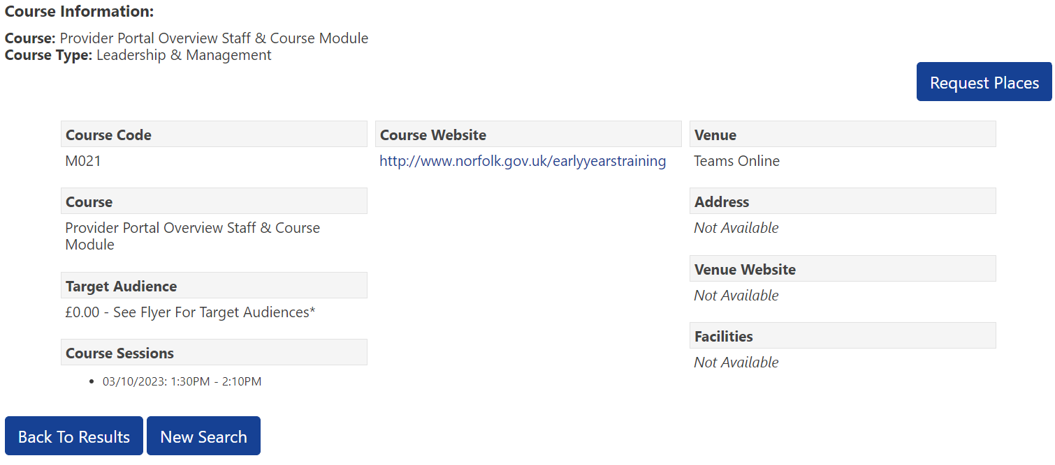 | training website  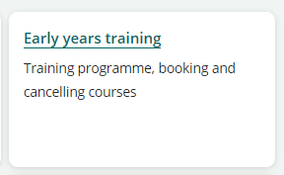

To request a place, click REQUEST PLACES

Your staff list will be displayed

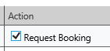
Tick REQUEST BOOKING to request a place for each member of staff that you wish to attend

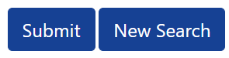
Click SUBMIT

The following message will be received

and the status will change to “Place Requested”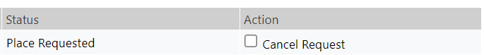

The status will not alter until your request (application) has been processed.

To check the status of your bookings

Click VIEW BOOKINGS

Amend the dates to suit your search and click FILTER
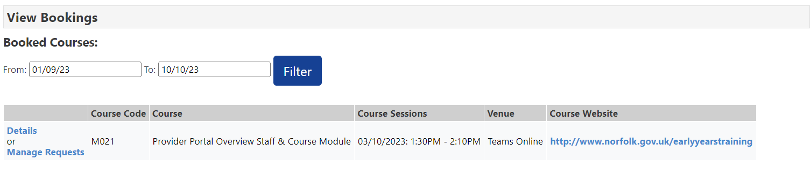

All courses where applications have been submitted will be listed

Click MANAGE REQUESTS to check who is booked
Course charges will apply to all listings which have a BOOKED status, and the course is not fully funded

The status will advise the progression of the application for a place.

If a place has been allocated the Status will be BOOKED, and an email confirmation will have been sent to the delegate.

Special Requirements
If a delegate has any special requirements, it is necessary to confirm this as part of their staff record. It is also recommended to contact the Training Team.
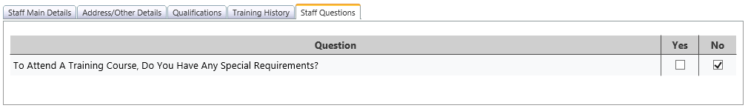
Places may be offered at short notice.

Waiting Lists
If a request is placed on a wait list. The status will remain as PLACE REQUESTED. An email will be sent to the delegate to confirm that they are on this list. If a place becomes available, the setting may be contacted, and a place offered.

Cancellations
It is possible to cancel a requested place directly on the Portal if the status is PLACE REQUESTED.

To cancel, tick CANCEL REQUEST and click SUBMIT
Cancellations within 24 hours and non-attendance will be charged at the full cost of the place. Please refer to our cancellation policy on the training website. charges will apply to all listings which have a BOOKED status and the course is not fully funded

The status will revert to NOT BOOKED.

The Local Authority will have no record of this action because this request will immediately delete your staff member from the course attendee list.

To cancel places which are BOOKED
Please email your details to earlyyearsandchildcare@norfolk.gov.uk

Top Tips!

- Subscribe to our newsletters, so that you are kept up to date about the provider portal.
- Ensure your staff records are maintained termly.
- Check booked places for staff leavers, and re-arrange attendance
- Pay invoices promptly to enable certificates to be issued.
- For system security, review termly access to the portal and use the PORTAL – Userid eForm to add, amend or delete an individual’s access.

Need Help!

Call the Advice Line on 01603 222300

An email message will be sent to confirm the cancellation. Please keep this as evidence that you have cancelled the place.

