The Forms Module is a means for the Early Years team to collect data via online forms. Some forms will have specific deadlines, particularly if the information required is for statutory purposes, others can by updated as required.

Please ensure your email address held by the Local Authority is current.

By completing the eForms available, it will –

- Update data held on the Norfolk Community Directory

- Display information held by Ofsted regarding the Early Years registration

- Support the Local Authority to meet their Statutory Duty under Sections 12 and 13 of the Childcare Act 2006

~ Section 12:
“To provide information, advice and assistance to parents and prospective parents on the provision of childcare in their area and other services which may be of benefit to parents, prospective parents or children and young persons in their area.”

~ Section 13:
“To provide information, advice and training to childcare providers.”

- Supports the Local Authority to meet the requirements of the Childrens & Families Act – Local Offer.

Since September 2014, every Local Authority must publish information about services they expect to be available in their area for children and young people, from birth to 25, who have Special Educational Needs and/or Disabilities (SEND).

Once logged in to the online system, click FORMS

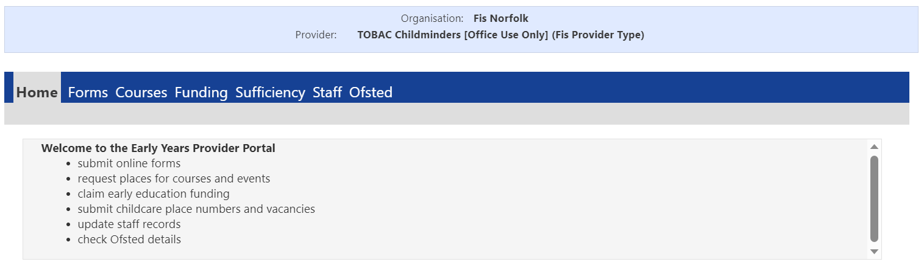

The main screen you will see will list all the eForms available for update.

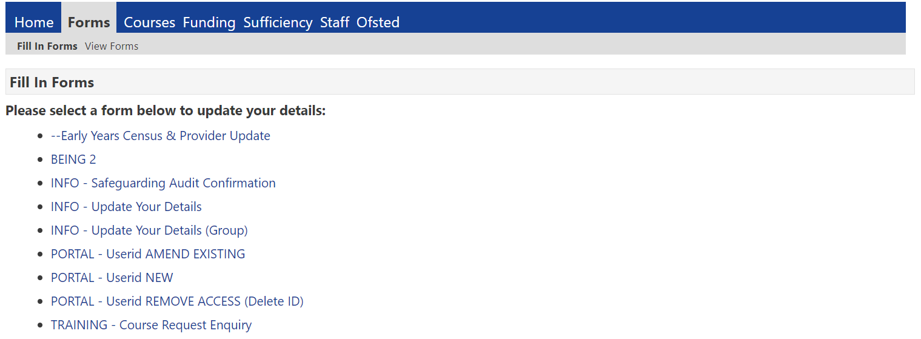

To complete an eForm
From the main screen, click the form to be updated. Once the form is selected, it will open in a new window for amendment.

To update the records, overtype the detail displayed in each field where required (the information displayed is the data currently held by the Local Authority).

Some fields may be view only (these will be coloured grey or marked “read only”)

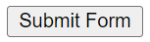
When all the data has been amended as required, select

The completed data will be reviewed and authorised.

Once authorisation is complete the information will be made available to the public via the Norfolk Directory where you have given consent, and/or collated for sufficiency data / government returns (eg. early years census).

To view the status of your submitted form, select VIEW FORMS

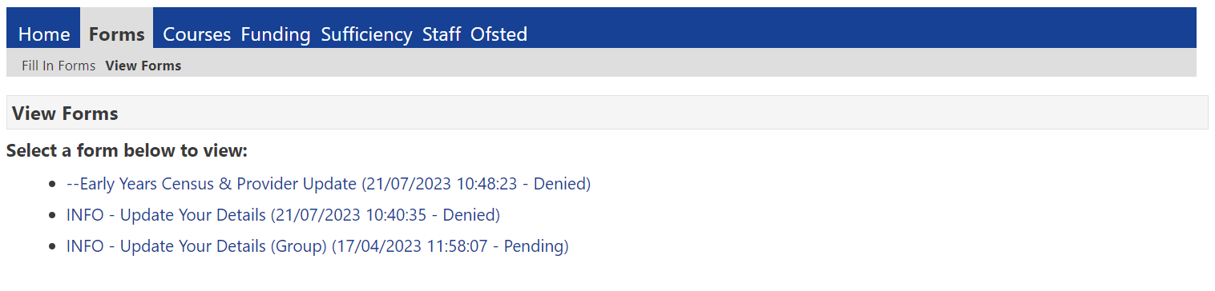

Whilst your eForm is “Pending”, it is possible to re-open the form by clicking the link to amend any detail, and then re-submit.

Top Tips!

- Subscribe to our newsletters, so that you are kept up to date about eForms and any deadlines to submit data.
- Review your business / group details at least annually and use the INFO – Update eForm to keep your information current.
- Keep narrative concise and limited to the maximum word count.
- Where applicable, seek consent before information is shared
- For system security, termly review access to the portal and use the PORTAL – Userid eForm to add, amend or delete an individual’s access

Need Help!

Call the Advice Line on 01603 222300

You will be contacted if your eForm cannot be accepted. The status for these forms will be “Denied”.

eForms which have been processed will denote as “Authorised.

