Financial Assessment Team
County Hall
NORWICH
NR1 2UE

Helpline: 01603 222133
Email: FAB@norfolk.gov.uk

Application Form for Disability Related Expenditure. You will need to fill in this form if you have expenses that you would like us to look at when we work out how much you pay for your care.

Name

Your I.D. Number

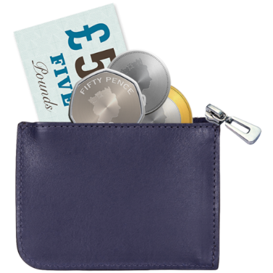
Please tell us how much money you spend on the following things

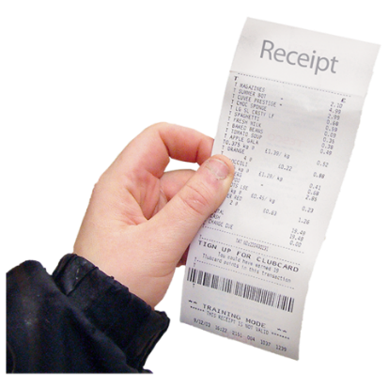

Please also send us copies of receipts,
bills or bank statements to show how
much you spend.

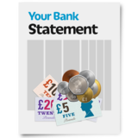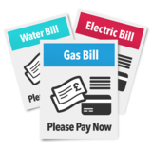

Community Alarm
How much do you spend on this?
£

Special washing powder and laundry that you need because of your disability
How much do you spend on this?
£
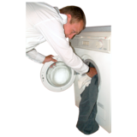

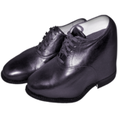
Extra money that you have to spend on
clothes and shoes because of your disability

How much do you spend on this?

£

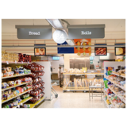
Special food that you need to eat because
of your illness

How much do you spend on this?

£

How much £

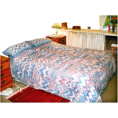
Additional cost where you have to pay for extra bedding due to incontinence.

How much do you spend on this?

£

Please note that you will also need to send us a letter from your doctor if you are claiming disability related expenditure for laundry, clothing, food or bedding as these are treated as specialist items and your doctor will need to confirm you need these because of your disability.

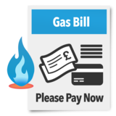
Heating or metered water if this is more than most people spend.
How much do you spend on this?
£

Cost of looking after your garden or cleaning your house if you are unable to do this and have to pay someone else to do it for you.
How much do you spend on this?
£
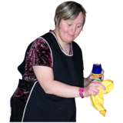

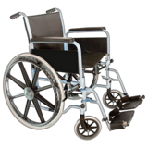
Money you have to spend to buy or repair equipment you need because of your disability. This could be for things such as a wheelchair.
How much do you spend on this?
£

£

How much?

Broadband (internet access) if you are blind or partially sighted.
How much do you spend on this?
£
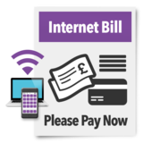

Any other items to do with your illness or disability. Please tell us what they are and how much they cost.
You will need to send us a letter from your doctor to confirm you need these items.
Details:

How much do you spend on this?
£

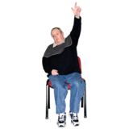

Remember – we can only look at the
money you want to claim if you send us
copies of receipts, bills or bank statements

Please return this form with the receipts
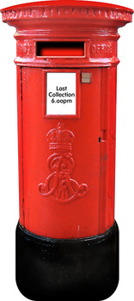
we have asked for and send them to this
address:

Norfolk County Council
Finance Exchequer Services
County Hall
Martineau Lane
Norwich. NR1 2UE
If it is easier you can scan this form and
receipts and email them to
dre@norfolk.gov.uk

More information about claiming Disability Related Expenditure

We can only take the amount you spend on disability related expenditure into account if:

The money you spend is for items you need
because of your illness or disability.

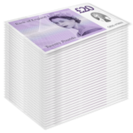
You spend more than most people would
spend for the same thing.

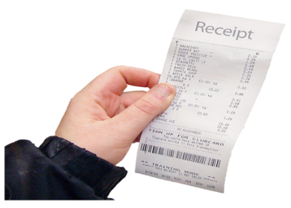
You have sent us the bills, receipts or bank statements we have asked for.

