SUPERFAST BROADBAND PROVISION

NORFOLK

STATE AID PUBLIC CONSULTATION

JULY 2018

OUTCOME REPORT

1. Introduction

The Better Broadband for Norfolk Programme is aiming to maximise the availability of Superfast Broadband (at least 30Mbps) across the county by the end of March 2021, subject to the budgetary constraints.

2. Outcome of the Public Consultation

The Public Consultation for the most recent phase of the Better Broadband for Norfolk Programme closed on 5th June 2018.

During the Consultation period the Better Broadband for Norfolk Programme contacted / was contacted by, nine suppliers.

- Six suppliers confirmed no response was intended to Better Broadband for Norfolk’s Open Market Review exercise

- Supplier A provided some additional detail on the premises that they serve. This has enabled the Better Broadband for Norfolk Programme to refine the Intervention Area

- Supplier B provided a refresh of their existing coverage since Better Broadband for Norfolk’s previous State aid consultation in 2014. It also provided information on planned commercial deployments. This resulted in some properties to be classified as BLUE ‘Under Review’.

- Supplier C approached the Better Broadband for Norfolk programme. It provided information on its planned commercial deployment within Norfolk. This resulted in some properties to be classified as BLUE ‘Under Review’.

Following this process, the intervention area for the project was updated and finalised prior to commencing the procurement. Week commencing 23rd July, the final State Aid maps and other detail for NGA Broadband and Basic Broadband will be made available on the project website at: https://www.betterbroadbandnorfolk.co.uk/further-information/

3. Timescales
The following table summarises the timescales of the next stages of the procurement:

State Aid Public Consultation 3rd April – 5th June 2018

Start of Procurement week commencing 23rd July 2018

State Aid notification (Part 2) expected to be submitted to DCMS, expected January 2019

Award superfast broadband contracts, expected February 2019

4. Revised State Aid Maps

The following criteria have been used by the Better Broadband for Norfolk Programme to determine the classification of areas into Basic Broadband and NGA White/Grey/Black/Blue areas respectively.
For basic broadband all postcodes are considered GREY, as Better Broadband for Norfolk is delivering a Universal Service Commitment to provide access to basic broadband speeds of at least 2Mbps to all premises in its geographic area

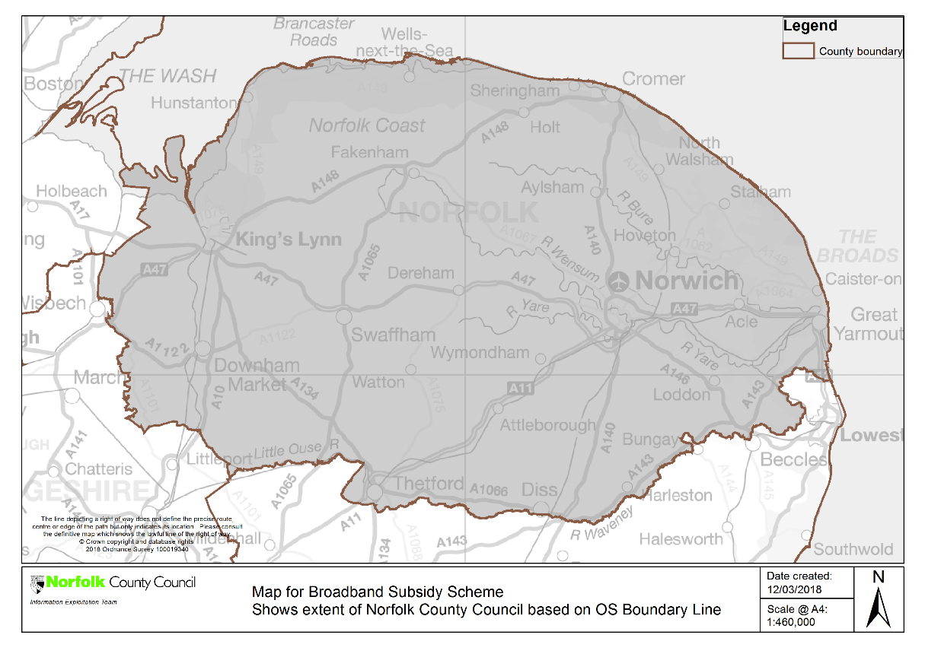

Better Broadband for Norfolk is doing this by using the BDUK locally administer ‘Better Broadband Scheme’ to provide a subsidy to applicants to connect to better broadband. These connections can be made from a range of private sector satellite, wireless and 4G broadband providers, applications can be made via the Better Broadband for Norfolk website at: https://www.betterbroadbandnorfolk.co.uk/better-broadband-subsidy-scheme/

For NGA a classification is awarded to each property:

- GREY, if there is only one broadband infrastructure operator providing NGA services (with speeds greater than 30Mbps)

- BLACK, if there are at least two broadband infrastructure operators providing NGA services (with speeds greater than 30Mbps)

- BLUE - Under Review (BLUE), properties where a supplier has indicated it has planned commercial coverage for NGA broadband. Properties that already have access to a speed between 24-30Mbps have also been classified as BLUE and account for a significant proportion of BLUE postcodes

- WHITE, a property does not have access to NGA broadband (30Mbps+) and none is planned via the BBfN rollout

The Better Broadband for Norfolk Programme sought premise level data from the market. This has been received in some cases but in the absence of consistent premise level data from all broadband infrastructure operators, Better Broadband for Norfolk has mapped areas as White, Grey, Black or Blue at a postcode level, using the following criteria:

Each postcode is allocated a classification based on

- GREY, if there is only one broadband infrastructure operator providing NGA services (with speeds greater than 30Mbps) for every property in that postcode area

- BLACK, if there are at least two broadband infrastructure operators providing NGA services (with speeds greater than 30Mbps) for every property in that postcode area

- BLUE - Under Review (BLUE), properties where a supplier has indicated it has planned commercial coverage for NGA broadband or already have access to a download speed of 24-30 Mbps. This applies even if only one property within the postcode area is BLUE

- WHITE, a property does not have access to NGA broadband (30Mbps+) and none is planned via the BBfN rollout. This applies even if only one property within the postcode area is WHITE and there are no BLUE premises within the postcode area

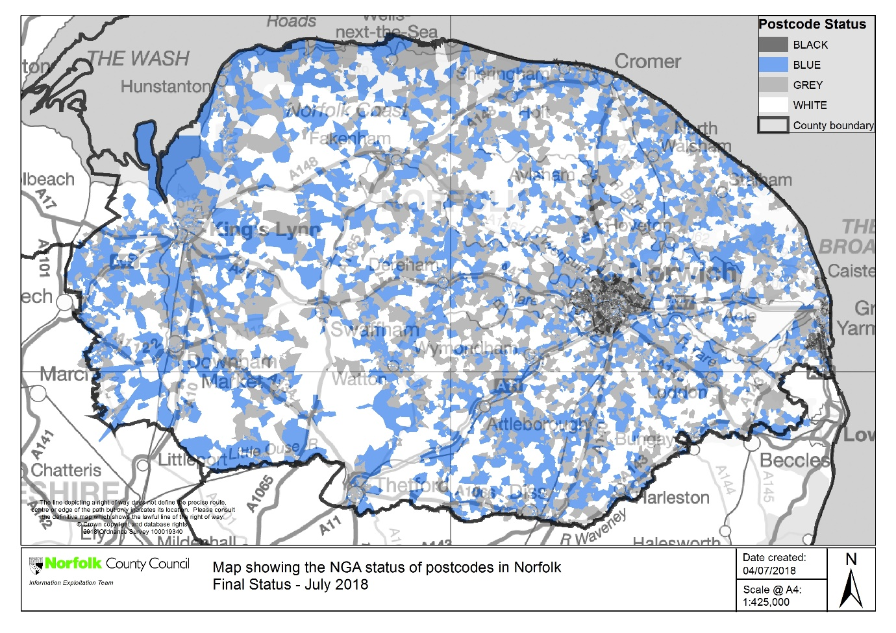
BLUE “under review” areas (coloured blue on the map). These areas contain premises where it has not been possible to confirm their existing or planned coverage for NGA broadband (i.e. mapped as NGA grey).

These premises have been reported through the OMR as being ‘at risk’ and will be subject to continued monitoring and verification of operator plans within the 3 year period by Better Broadband for Norfolk. In the event that these commercial plans fall away or properties are found not to be served, these premises will be mapped as NGA WHITE and form part of the proposed intervention area and eligible for intervention via this aid measure
.

The following table summarises the outcome of the State aid consultation in terms of BLUE,
‘Under Review’ WHITE, GREY and BLACK postcodes / premises for Superfast Broadband at 30Mbps:

Postcode status | Postcode | Black THP | Grey THP | White THP | BLUE THP | Total THP
Black | 3,644 | 82,443 | 0 | 0 | 0 | 82,443
Grey | 15,440 | 19,568 | 236,376 | 0 | 0 | 255,944
White | 3,627 | 0 | 14,600 | 19,510 | 0 | 34,110
BLUE | 4,450 | 0 | 67,352 | 8,605 | 21,447 | 97,404
 | 27,161 | 102,011 | 318,328 | 28,115 | 21,447 | 469,901

For contract 3, Better Broadband for Norfolk intends to procure coverage to target ‘WHITE NGA’ premises by conducting a new procurement under the 2016 NBS (and in accordance with the Public Contracts Regulations 2015). As noted above, if commercial plans do not materialize for “under review” BLUE properties then these will be considered as eligible for intervention and considered as ‘WHITE NGA’ premises.

Better Broadband for Norfolk intend to make coverage information available at a WHITE / BLUE premise level to ensure that bids can target those premises without NGA broadband coverage efficiently. This will include information at a premise level received in response to this consultation.

Better Broadband for Norfolk intention is to provide at least a doubling of speeds, in accordance with the requirements of the 2016 NBS.

Better Broadband for Norfolk will focus on premises that are less than 24Mbps which have not benefited from NGA uplift through commercial or other previous Better Broadband for Norfolk deployments. This means properties with access to properties of 24-30Mbps have been classified as BLUE

It should be noted that whilst this consultation includes mapping of basic broadband coverage, the procurement will not deploy basic broadband technologies.

5. Status of Intervention Area

The State Aid Public Consultation is now closed. Better Broadband for Norfolk submitted its State aid (Part 1) notification to the National Competence Centre (part of the Department for Culture Media and Sport) which oversees the UK National Broadband Scheme.

A decision on the eligibility of the proposed Intervention Area was given on 19th July 2018. Clearance was granted, the Intervention Area mapped above is therefore confirmed as eligible for public sector intervention for the next stage of the Better Broadband for Norfolk Programme, including the forthcoming Phase 3 procurement. This confirmed new Intervention Area will be published on the project website.

6. Contact Details for Further Information

Up-to-date information about the Better Broadband for Norfolk Programme can be found at
https://www.betterbroadbandnorfolk.co.uk/map/

